Position Title | Social and Emotional Wellbeing Manager
Location | Townsville
Work Unit | Primary Care
Position Reports To | Director of Health Services
Positions Responsible For | Social workers  Counsellors  Support workers  Alcohol and Drug counsellors
Award Reference | Aboriginal and Torres Strait Islander Health Workers and Aboriginal Community Controlled Health Services Award
Date of Approval | March 2026

About TAIHS

TAIHS is an Aboriginal and Torres Strait Islander community controlled and managed corporation. With approximately two hundred employees and an operating income of $30m generated from Commonwealth and State funding bodies. The organisation supports communities in the Townsville, Ingham, Burdekin, Charters Towers and Hughenden areas.

TAIHS provides a holistic primary health care service incorporating a bulk-billing general practice medical clinic, a dental clinic, an individual support and advice service, mental health counselling, community health screening and health promotion activities. TAIHS also provides a range of community services, including crisis accommodation, child safety and early family intervention programs, and specialist services for young people.

In addition to the operation of comprehensive primary health services and the provision of a range of community services, TAIHS seeks to improve health and social outcomes for the community through strategic partnerships advocacy for needs, promotion of awareness and education in improved health and social practices, the promotion of knowledge and understanding of underlying issues to address the unique patient and client needs and the development of evidence-based practices.

Our Vision – “TAIHS … More than a Health Service”

To “strive to provide a truly comprehensive model of care that responds to the physical, social, emotional, cultural and spiritual needs of our people”.

Our Purpose

Lead the way in providing culturally accessible, integrated health and social support services to our people so that they can live healthier, stronger, and longer lives, preserving our oldest surviving culture for future generations.

Our Values

- Cultural Governance… Responsive, Leadership, Integrity
- Accountable… Respect, Responsible, Outcome Focused
- Collaborative… Partnerships, Integration, Engaged
- Innovative… Creative, Courageous, Sustainable
- Evidence-Based… Ethical, Transparent, Improvement
- Empowerment… Advocate, Motivate, Communicate

Our Strategic Pillars

- Access and Capability – improving access to high quality, inclusive health and human services that are culturally safe and responsive

- Innovation and Transformation – translating knowledge into action by championing creative approaches to planning, designing and delivering health and human services

- Culture and Community – reflecting Aboriginal and Torres Strait Islander people’s cultural values throughout the organisation’s policies, practices and relationships

- People – strengthening and empowering our capability, practices, and every community member to engage in culturally responsive ways

- Sustainability and Governance – strengthening and enhancing our foundation for long success, stewardship and influence

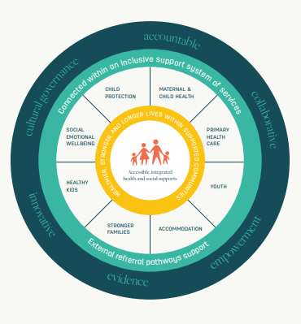
Our Services

Corporate Services

Primary Care

Community Services

Your Contribution

The primary objective of the position is to manage the social and emotional well-being (SEWB) contracts and staff working in the social and emotional well-being programs.
The SEWB Manager is responsible for the management of social, emotional and mental wellbeing and support worker staff and services. The SEWB Manager works closely to collaborate with the TAIHS clinical mental Health Manager and services collocated on the TAIHS Garbutt site.

Key Responsibilities and Accountabilities

Duties & Responsibilities of the Social and Emotional Wellbeing Manager:

- Leadership of TAIHS SEWB programs
- Collaborate with Clinical Mental Health Manager
- Leadership to develop community-led group work and activities to foster wellbeing
- Manage SEWB contracts, including budgets and reporting compliances
- Lead and manage SEWB teams and staff
- Collaborate with the Primary Health team in leading health and well-being initiatives
- Lead with positivity to achieve cooperation, professionalism and respect between the health professional teams
- Manage SEWB rosters to ensure support staff are available across clinic opening hours
- Ensure accurate documentation of all client encounters
- Ensure patients are booked in correctly, and patient follow-up care and safety plan arrangements are put in place before patients leave the clinic
- Lead quality improvements in SEWB programs to ensure that TAIHS provides accessible and culturally safe SEWB services to meet the needs of the community
- Ensure compliance with workplace health and safety legislation and best practice
- Lead and foster a culture of excellence in cultural safety and primary health care
- Lead patient journey and flow to optimise clients’ experience of the health service
- Proactively seek, monitor and evaluate patient feedback and provide timely reports and escalation to the Director of Health Services
- Work cooperatively and collaboratively with other TAIHS managers and programs
- Collaborate and work collectively with the Primary Health Care senior leadership team
- Support the Director of Health Services

Required Qualifications and Experience
- Cert IV/Diploma/Qualification in Counselling, Community services, Social Work or other relevant qualification
- Experience working with Aboriginal and Torres Strait Islander patients
- High cultural capability
- Demonstrated leadership within a multi-disciplinary team
- Experience working with Data systems
- Demonstrated ability to determine priorities and manage workloads within a dynamic clinic environment
- Demonstrated application for professional and ethical standards

Required Licenses and Checks
- Current Paid Working with Children / Blue card
- Ability to pass a National Police Check – no Serious/Criminal/Court Records
- Current C Class Drivers License (Qld)

- Current Basic Life Support (BLS) certificate (within 12 months)

Required capabilities
- Broad cultural capability
- Advanced listening and communication skills
- Advanced Interpersonal skills which engender mutual respect with staff, clients and stakeholders
- High level of emotional intelligence
- Ability to problem solve within a complex setting
- Ability to positively foster success within a supported team environment

TAIHS Leadership Framework

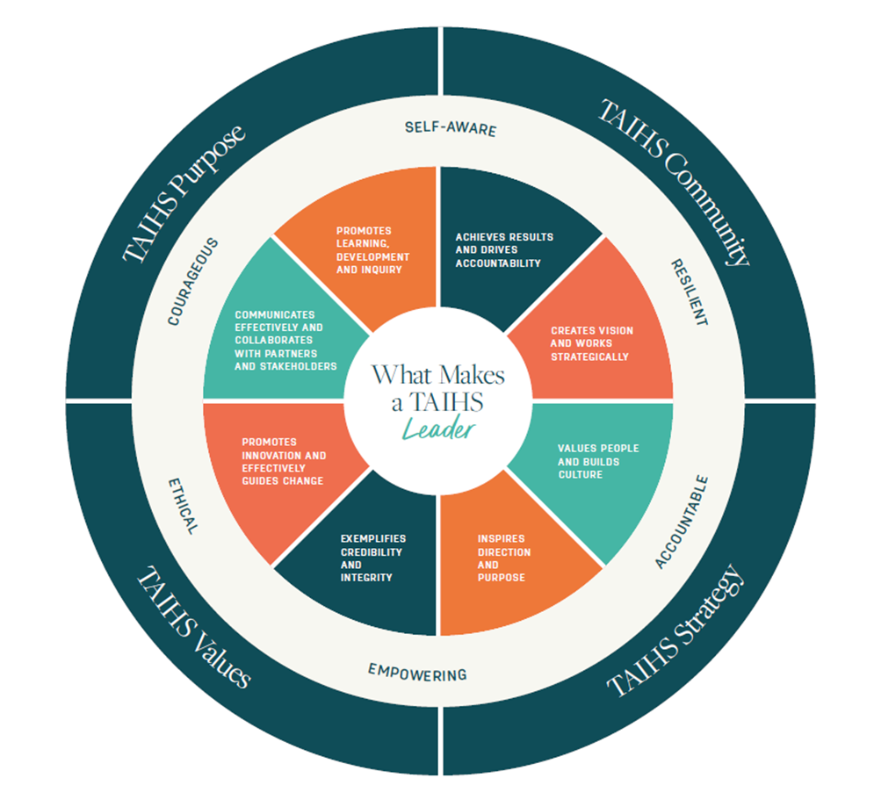

The TAIHS Leadership Capability Framework identifies the 6 attributes of self-awareness, resilience, accountability, empowerment, ethical and courage as the qualities and behaviours that epitomise effective leadership within TAIHS.
For leaders and aspiring leaders within TAIHS, supporting services and teams and driving change requires a strong capacity for action and an equally strong capacity for understanding and delivering with constraints. The TAIHS leadership attributes enable leaders to stabilise and drive efficiencies through the challenges that come with leadership.
The TAIHS Leadership Framework identifies 8 key capabilities that define leadership in the TAIHS context:
- values people and builds culture
- creates vision and works strategically
- achieves results and drives accountability
- promotes learning, development and inquiry
- communicates effectively and collaborates with partners and stakeholders
- promotes innovation and effectively guides change
- exemplifies credibility and integrity
- inspires direction and purpose

The framework is designed to:
- provide an understanding of what TAIHS expects of its leaders and aspirant leaders
- help build a common understanding of leadership acumen within TAIHS
- support leadership development and opportunity within TAIHS
- assist in the integration of leadership at the various levels into the culture of TAIHS
- align with TAIHS strategic direction, mission, vision, values and workforce plan

Areas of Focus:

Team Management
- Direct management of SEWB staff
- Apply optimal rostering practices to ensure adequate service staffing to cover all opening hours
- Ensure appropriate supervision is provided to staff and trainees
- Oversee induction, training and support for staff
- Foster a positive and inclusive workplace culture

Health Care Service Delivery
- Perform all operational activities in an effective and efficient manner
- Support director of health services
- Manage SEWB services
- Supervise and support trainees

Financial Management:
- Manage SEWB contracts and budgets

Relationship Management:
- Foster productive working relationships with other TAIHS staff in the delivery of seamless support services
- Work in partnership with all TAIHS managers and leads to support staffing, resources and consistent practices to support the operational success of the organisation

Information Management:
- Maintain the information flow that supports reliable data and documentation in your area of responsibility
- Ensure accurate, timely and complete documentation of all patient encounters

Safety:
- Report any work-related personal injuries/illness or incidents, safety hazards, malfunction of any machinery, plant or equipment
- Demonstrate leadership in TAIHS Work Health Safety goals and objectives remaining compliant with WHS Legislation and TAIHS policies and procedures
- Carry out your duties safely in accordance with your ability and competence

Legal Obligation:
- All relevant health professionals who, in the course of their duties, formulate a reasonable suspicion that a child or young person has been abused or neglected in their home/community environment, have a legislative and a duty of care obligation to immediately report such concerns to the Department of Child Safety

ALL employees have a commitment to adhere to the following:

- Work collaboratively with other team members and the wider TAIHS community in a manner that fosters positive reputation, relationships and workplace culture
- Work within legal, ethical and professional frameworks
- Ensure a commitment to all lawful and reasonable directions
- Actively endeavour to meet personal performance expectations and standards
- Participate in relevant meetings (organisation and team)
- Participate in required training and professional development programs
- Actively monitor, review and assist with improvements to policy, procedure, process and practice across TAIHS - All employees share the authority and responsibility of identifying non-compliances or possible improvements and recording these instances such that corrective or preventive action can be taken, to rectify the immediate situation and to prevent recurrence
- Commit to self-development and self-awareness to support professional growth
- Work in accordance with the TAIHS Code of Conduct and values, workplace health and safety legislation, confidentiality policies and all other relevant policies, procedures and processes
- Undertake other duties as reasonably directed

Please note that the duties outlined in this position description are not exhaustive and only provide an indication of the work involved. To achieve business needs TAIHS can direct you to perform duties which it considers are within your level of skill, competence and training.

Working Relationships
This position reports directly to the Director of Health Services and works collaboratively with peers.

Delegations
As outlined within the Delegations Register.

Practical Requirements
- Be available to work onsite at Garbutt between 8am to 5pm Monday to Friday
- Ability to perform the physical requirements of the position in a safe manner

Conditions and Benefits of the Position

TAIHS provides access to an employee assistance program and access to learning and development opportunities. Your employment experience with TAIHS will include work-life balance with competitive salary and benefits, leave entitlements, career progression opportunities and the chance to make a difference to the people and communities.

TAIHS is committed to building an inclusive culture that respects and promotes human rights and diversity. The position involves working with a multicultural organisation where the majority of employees, clients and stakeholders identify as Aboriginal or Torres Strait Islander. Employees demonstrate an understanding of the issues affecting Aboriginal and Torres Strait Islander people communicate effectively and empower Aboriginal and Torres Strait Islander people.

TAIHS acknowledges that we respectfully journey together to aspire to be a culturally capable organisation. We are an inclusive, equal employment opportunity employer and place value on our diverse workforce. We encourage applicants representing all genders, ethnicities, ages, languages, sexual orientations, people with a disability, and those with family responsibilities to apply.


